**Practical 1**

1. Describe basic structure of HTML document
2. Write an html code to create 4 heading from h1 to h4, four paragraph in which first paragraph should be bold, second should be italic and third should be underline.
3. Write a html code to create one heading with center align, five paragraph which should contains some superscript and subscript values in paragraph first, big and strong tags in paragraph two, <em> tag, line break, horizontal line in paragraph three, <pre> tag. Block quote in paragraph four and abbr, dfn, address tag and comments in paragraph 5. All the paragraph should be in center.
4. Write a html code to create any number of paragraphs of your choice but all the paragraph should include symbol like greater than (>), less than (<) fraction, copyright, degree, single quote, double quote.
5. Write a html code to that contains three paragraphs in which first paragraph should start from left, second from center and third from right side.

**Practical 2**

1. Show a HTML code to create order list with its different values types like (1,2,3,4, a,b,c,d, I,II,III etc.). after this also give example on start attribute of list
2. Show a HTML code to create unordered list with its different symbols like circle, square etc.
3. Display following nested list using HTML

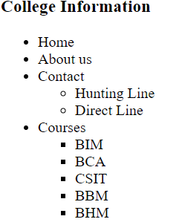

1. Write HTML code to create following list:

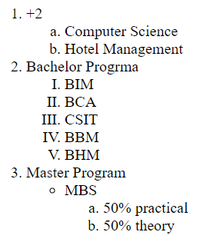

1. Write a HTML code to display following table:

**Fruit Juice Drink**

|  |  |  |  |
| --- | --- | --- | --- |
|  | **Apple** | **Orange** | **Banana** |
| **Breakfast** | 0 | 1 | 0 |
| **Lunch** | 1 | 0 | 0 |
| **Dinner** | 0 | 0 | 1 |

1. Write a html code for following

|  |  |
| --- | --- |
| **Name** | **Address** |
| IT College | KTM |
| Pokhara |

1. Write a HTML code for following

|  |  |  |
| --- | --- | --- |
| Number | Prefix | Symbol |
| 101 | *deka-* | da |
| 102 | *hecto-* | h |
| 103 | *kilo-* | k |

1. Write a HTML code for following table: add your own data (at least 5)

|  |  |  |  |  |  |  |  |
| --- | --- | --- | --- | --- | --- | --- | --- |
| **SNo.** | **Campus code** | **Name of student** | **TU Reg.** | **Gender** | **Subject code and Internal marks** | | |
| **Subject code** | **Subject code** | **Subject code** |
|  |  |  |  |  |  |  |  |
|  |  |  |  |  |  |  |  |

1. Write a HTML code for following

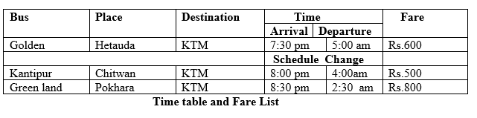

1. Write a program to demonstrate use of splitting a table (thead, tbody, tfoot)
2. Write a program to demonstrate cell-padding and cell spacing attribute of table

**Practical 3**

**Creating a Form**

* Make a form using html which should contains four text box, one multiple line text box and a check box.
* Make a form using html having border and heading. A form should contain two text boxes mentioning their size and maximum number of characters a user can enter, one radio button, one checkbox and two buttons.
* Make a complete form using html in which each text box should contains size, maximum length and make any two of the text boxes read only. When a form is submitted, it should redirect to result.html and also should contains method. Use table to keep position of control in exact order.
* Make a form using HTML which should contains date field, email field, URL field, read only and disabled field.

**Practical 4**

**Cascading Style Sheet (CSS)**

1. Give an example of inline CSS of your choice. ( use atleast 5 html elements)
2. Give an example of internal CSS. ( use atleast 5 html elements)
3. Give an example of external CSS. ( use atleast 5 html elements)
4. Create one division which should contains one heading and three paragraphs. Use external CSS to give example of all text formatting styles.
5. Give an example of all CSS selectors. Use atleast 5 html elements
6. Make a following layout using division and external CSS.

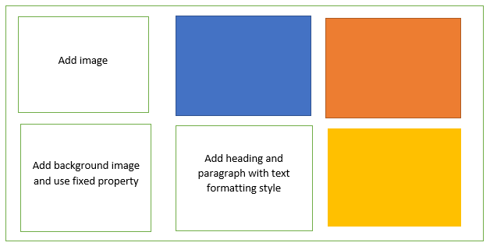

1. Use division and external CSS to create following layout:

